INTERNATIONAL CONTEST
Sustainability in Architecture Construction and Design in Baltics 2022
Application requirements

Organizer: 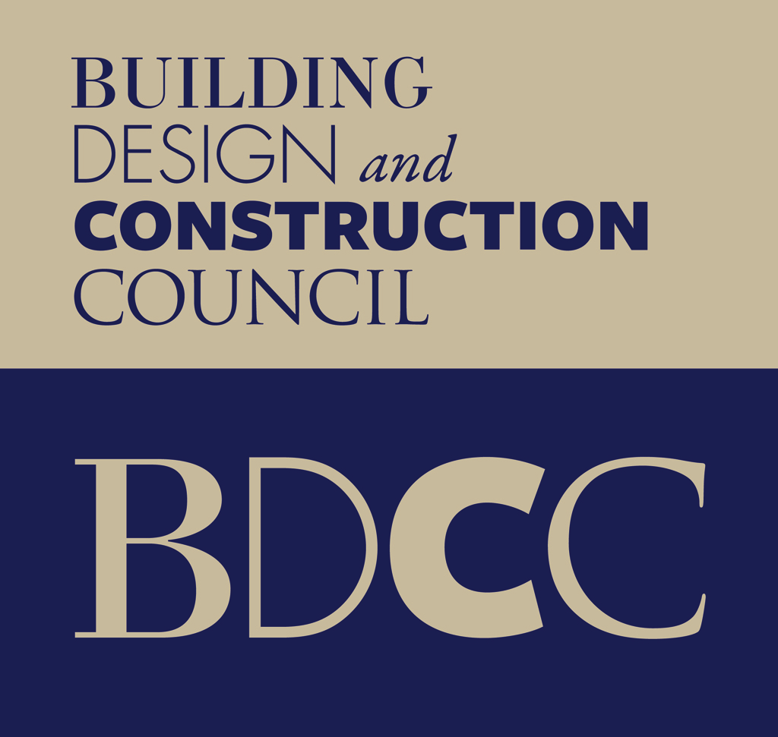 www.buvniekupadome.lv

In cooperation with: State Construction Control Bureau of Latvia www.bvkb.gov.lv/en

- Organizers and partners
- Organizer: Association Building Design and Construction Council (BDCC, www.buvniekupadome.lv).
- Patron: Inese Vaidere, Member of the European Parliament for Latvia, Member of The New European Bauhaus initiative.
- Jury
- Hadley Barrett, experienced developer of sustainable properties, renewable energy, the CEO of the Oxford Sustainable Group
- Publicist Agrita Lūse, member of the board of the association Building Design and Construction council
- Architect Uldis Balodis
- Architect Līga Rutka, licensed BREEAM assessor
- Sandris Celmiņš, State Construction Control Bureau of Latvia, Head of Construction Work Control Division
- Edgars Krasņikovs, construction supervisor, licensed BREEAM assessor
- Gintars Dardets, builder of BREEAM certified projects, member of the association Building Design and Construction Council
- Igors Golubevs, Head of Schneider Electric
- Rimants Giedraitis, architect, Lietuva
- Dmitrijs Kots, builder, VNĪ, BIM specialist
- Mission
Promoting the idea of ​​sustainable construction, architecture and design. Educating the society by highlighting the best practices, as well as sharing information on the success factors of such projects. Draw attention to available resources required for sustainable building implementation. Share information, experience, knowledge and ideas on sustainable development of buildings, urban environment and requirements in the context of Baltic States.
- Nominations
The Most Sustainable Building
Requirements for submitting: public and private buildings that have been put into operation until September 1, 2021.
The Most Sustainable Landscaping
Requirements for submitting: landscaping that has been put into operation until September 1, 2021.
The Most Sustainable Project
Requirements for submitting: projects (buildings, objects, and landscaping projects) that have been developed until May 1, 2022.
The Most Sustainable Student Idea
Requirements for submitting: college and university students, graduates, that have graduated in the last 5 years and aren’t considered to be certified architects, artists, designers, engineers.
Applicable for submitting are the following: projects, sketches, designs, proposals for functional design objects that have been created as a part of the study program or exclusively for the Contest, or are implemented within the framework of the project submitted to the Contest.
- Application
Applications for the Contest are to be submitted by any private person (person group) or legal entity no later than by 30 June 2022.
Applications must be submitted electronically in Latvian or English language in Word or PDF format, separately attaching photos in JPG format. Materials have to be sent to either one of these emails: agrita.luse@gmail.com or gunita.jansone@inbox.lv .
For more information, please contact organizers - Agrita Lūse, +371 28373794; Gunita Jansone, +371 29407147.

5.1. Application components
Application form (see ANNEX 1);
Description template for buildings, projects, and landscaping (see ANNEX 2);
Description template for student ideas (see ANNEX 3).
Participants of the Contest are fully responsible for the authenticity of the information submitted in the application and its compliance with the conditions and procedures of the Contest regulations.
- Awards
The winners of the Contest are awarded diplomas and special prizes. The winners of the 1st place in addition to a diploma receive an award - a decorative custom-made wooden design work. The winner of The Most Sustainable Building nomination will receive an appreciation plaque with an individual inscription for the award to be attached to the building.
- Publicity
In cooperation with the Contest’s patron, the Contest and its participants will be given wide publicity. Participants' applications - buildings, projects, landscaping, and ideas will be announced publicly on the miscellaneous news and industry websites of Latvia, Lithuania, Estonia, and other contest materials. Information about the winners' projects will be used for informative and educational purposes in universities and the professional community.
ANNEX NR.1. – APPLICATION FORM
Nomination
Name of the project and address
Contact person - name, surname, company, position, address, e-mail, mob. phone.
Short description of the building, landscaping, sketch, or design object, providing precise information about the project and its message.
List of architects, engineers, and students that have taken part in project or idea implementation, providing their contact details: e-mail, mob. phone.
Project customer and its contact details: e-mail, mob. phone.

ANNEX NR. 2
Description template for The Most Sustainable Building, The Most Sustainable Landscape, The Most Sustainable Project.
Criterion 1. - Site selection and location, landscaping or public outdoor space functionality and environmental context.
Description in free form, not exceeding 3'000 characters (including space). Plus - explanatory note, visualizations as separate jpg files and master plan.

Criterion 2. - Energy efficiency of the buildings
Energy consumption required for servicing, maintenance and light of a landscaping or public outdoor space object.
Description in free form, not exceeding 3'000 characters (including space).

Criterion 3. - Efficient use of water resources
Description in free form, not exceeding 3'000 characters (including space).

Criterion 4. – Use of construction materials, sustainability characteristics and origin components
Description in free form, not exceeding 3'000 characters (including space).

Criterion 5. - Waste reduction in construction and maintenance
Description in free form, not exceeding 3'000 characters (including space).

Criterion 6. - Transport and mobility for buildings. Environmental accessibility of landscaping or public outdoor space.
Description in free form, not exceeding 3'000 characters (including space).

Criterion 7. - Quality of the indoor environment. Environmental quality for landscaping or public outdoor space.
Description in free form, not exceeding 3'000 characters (including space).

Criterion 8. - Social and economical benefits

Description in free form, not exceeding 3'000 characters (including space).

Criterion 9. - Innovative solutions
Description in free form, not exceeding 3'000 characters (including space).

Criterion 10 – Compliance with the concept "Building of the Future". The applicant lists the technologies planned or already used in the development of the project, which indicate the compliance of the building with the “Building of the Future” concept.

“Building of the Future” concept

Resilient
In commercial real estate, it is critical to minimize risk in your portfolio. With solutions that offer operational flexibility, remote operations, and maintenance, facilitate re-entry and cybersecurity, and ensure power reliability, you can maximize net operating income (NOI), attract and retain tenants, and enable the successful return to the workplace.
Because in commercial real estate, no time is a good time for downtime.
IoT solution | Description | Yes/No, short description | 1-5 points
Remote operations and maintenance | Proactively maintain your real estate portfolio with remote building operations and maintenance services. Gain key insights into building operations by constantly monitoring systems and identifying faults to proactively address building inefficiencies. Ex: BMS, Predictive maintennce.
Operational Technology (OT) Cybersecurity | The threat of cyber attacks against building management systems is a growing concern.
Risk mitigation and compliance strategies | With ever-evolving energy and sustainability regulations at the local, regional, and global levels, it’s more important than ever to have a compliance and risk mitigation strategy. Meet the requirements of sustainable building certifications and reporting and demonstrate effective governance of your commercial real estate properties. Ex.:Power management systems/reporting tools
Power Reliability | With the digitization of building systems and the usage of digital tools by building occupants, commercial buildings are dependent more dependent than ever on reliable power.  Digitization of the electrical distribution system helps bring greater visibility and insights to facilitate the decision-making process. It also helps demystify complex power quality issues that can affect the operations and longevity of your commercial real estate assets. Ex: Power quality management system.
Hyper-efficient
Solutions that enable real-time, data-driven decisions and optimize asset availability and performance through predictive analytics and proactive maintenance, so your operations are more productive and profitable.
IoT solution | Description | Yes/No, short description | 1-5 points
Occupant productivity solutions | For CRE to be attractive to tenants, it must be comfortable and enable the health and well-being of its occupants.
Space allocation solutions | Identify and reallocate underutilized desks, offices, meeting rooms, and amenities with real-time data to maximize space resources in your commercial real estate property.
Asset efficiency | Make your real estate assets “remote service ready” to identify equipment issues earlier and minimize disruptions with automated fault detection. For real impact on operating costs, occupant comfort, and asset value, you need systems performing optimally with limited budgetary and maintenance resources.
Sustainable
Meet the requirements of sustainable building certifications and reporting and demonstrate effective governance of your commercial real estate properties.
IoT solution | Description | Yes/No, short description | 1-5 points
Alternative Renewable power sources | Ex.: solar, wind
Validate carbon emission reduction progress | Regulatory and reporting requirements now consist of validation, alongside disclosure of carbon emission reduction.
Net-zero buildings | Ensuring your assets are delivering on your net-zero strategy is a sure path to success in the modern real estate sector.
Green building certifications | Green building certifications are an integral component in most asset management practices.
People-centric
Corporate occupiers want to lease the safest, healthiest, and most engaging spaces for their people. Because in commercial real estate, occupant health and well-being mean greater productivity.
IoT solution | Description | Yes/No, short description | 1-5 points
Healthy buildings | Enhance occupant well-being and increase productivity by monitoring temperature, humidity, CO2, noise, light, and VOC levels.
Return to the worklplace | There will undoubtedly be a new level of regulatory scrutiny and demand for many building practices — enhanced sanitation, social distancing, HVAC performance — that didn’t exist before the pandemic.
Operational flexibility | Maximize NOI (Net Operating Income) of your commercial properties by making your buildings smart and agile, enabling tenant attraction and retention and an efficient to return to the workplace. Smart workplace solutions facilitate people count, socially distanced workspaces and ensure real-time communication to keep building occupants comfortable and productive.

ANNEX NR. 3.
Description form for the nomination The Most Sustainable Student Idea

Description in free form, not exceeding 10' 000 characters (including space).

